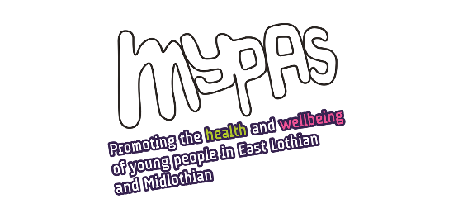

**Job Title: Fundraising Manager**

**Employer:** Board of Directors, Midlothian Young Peoples Advice Service

**Responsible for:** Office and Communications Administrator

Charity Administrator

**Responsible to: MYPAS Chief Executive**

**Salary:** £35,165 - £37,178

**Hours:** 35 per week. Some Evening and Weekend work may be necessary – based on advance notice and a TOIL system. The post requires flexibility during peak fundraising periods such as seasonal events and MYPAS run community events.

**Leave:** 26 days annual leave + 10 public holidays, to be worked flexibly to suit the needs of the service

**Place of work:** The administrative base is in Dalkeith. Travel throughout Midlothian, East Lothian and the Scottish Borders including operating from other venues, may be required on an occasional basis. The post may have elements of hybrid working principles which may include home working as convenient for both parties, other MYPAS office space and other UK based locations as necessary.

**Length of contract:**The post is funded for an initial fixed term for one year. – this is not dependent on meeting fundraising targets.

**Main purpose of role:**

To develop and lead our fundraising strategy, drive income growth and diversify our funding streams.

A creative problem-solver with a proven track record in securing funding from a variety of sources. Responsible for building strong relationships with our supporters and stakeholders, and managing all aspects of our fundraising activities.

This is a new post working with the Chief Executive, Service Management Team, the Ambassadors group, the Board, and the wider staff team to grow fundraising, and to establish a fundraising culture across the organisation.

With a primary focus on fundraising, the postholder will also work to support marketing and communications including developing social media.

**Key Responsibilities:**

* Supporter-Led Events and Challenge Fundraising: Develop and implement a strategy to grow income from community events and challenge fundraising activities
* Individual Giving: Establish and manage a comprehensive individual giving programme, including regular giving and project funding campaigns, major donor engagement, and legacy giving
* Trusts, Foundations, and Tenders: Research, write, and submit compelling applications and reports to charitable trusts and foundations. Assist the Chief Executive in the preparation of tenders for relevant funding opportunities
* Corporate Giving: Identify, approach, and build relationships with corporate partners to secure financial support and in-kind donations
* Marketing and Communications: Develop and execute fundraising marketing materials, including digital and print campaigns, to engage supporters and promote fundraising initiatives. Work with the Chief Executive and the administration team to develop the website and social media presence
* Database Management: Establish and maintain a secure and efficient donor database, ensuring full compliance with GDPR and other data protection regulations

**Essential:**

* Track record of successful fundraising across more than one area of fundraising (e.g. individual giving, community, events etc)
* Excellent interpersonal skills, and the ability to communicate with a range of people across different channels including face to face and in writing
* Well-organised with close attention to detail and experience of managing administrative systems and processes
* Experience of setting targets and budgets
* Experience of working to strict deadlines, and confident at multi-tasking, working on multiple projects simultaneously with varying deadlines
* Excellent computer skills and experience of using a wide range of computer packages, including Microsoft packages
* Knowledge of current fundraising legislation and GDPR regulations
* Non-judgemental approach to working with young people, families, staff, board and stakeholders

**Desirable:**

* Experience of marketing and comms including social media
* Experience of planning and running successful events
* An understanding of the challenges of working with mental health, substance use, LGBTQ+ and young people